Anglo Portuguese School of London
14th September 2020
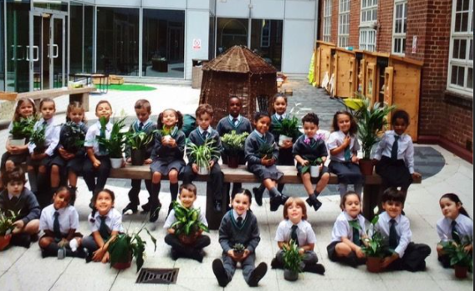

At APSoL this week;
We have had a busy week this week, learning about each other. As part of our topic ‘All About Me’, we have drawn our self-portraits, practised writing our names and written about our families. We also talked about our emotions.  Outside, the children have enjoyed engaging in water and sand play. Whilst playing with the water, the children have been creating their own structures, using pipes, as well as investigating the different ways water can travel. In the sand, the children have been showing an interest in burying objects. The children have also been experimenting with moving safely over an obstacle course.  We have also started our phonics (teaching of sounds/early reading). We will be communicating soon about how you can support at home. Phonics is taught in small groups according to reading ability (phonics awareness).  As part of the children’s transition, we have continued to talk about our classroom agreements and expectations whilst playing and learning together.  Some of these include:  We are kind to each other  We raise our hands when we want to share our ideas  We use our walking feet inside  We always try our best |  | Português  Nas aulas de Português desta semana estivemos a aprender o nome das partes do corpo sob o tema “Tudo sobre mim”.  Praticámos os cumprimentos pessoais e também fizemos uma sessão de partilha de informações sobre os objetos culturais trazidos pelas crianças.  Esta diversidade cultural é o que nos enriquece como escola!  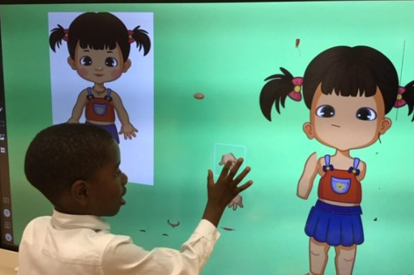  Plants  Thank you for bringing an air-purifying plant to school on your child’s first full day! These have really brightened up the learning environment and are a great way of teaching children how to look after plants and their importance.
Uniform:
We pride ourselves in our uniform. Please ensure that children wear their blazer to and from school. We are happy for jumpers to be left at home or in your child’s bag whilst the weather is still good. Os blazers têm que ser usados para a escola todos os dias.

Reminders:
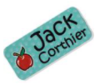
Named items
Please label all items of your child’s clothing with their name. This includes PE kits and blazers. Por favor coloquem o nome do seu/sua filho/a em todas as peças de vestuário.
PE Kits
As quartas-feiras os meninos tem ginástica. Por isso, agradecíamos que trouxessem o fato de treino e t-shirt vestido para a escola nesse dia.
The children will have PE on a Wednesday afternoon, we ask that children come to school wearing their PE kits in the morning. Please ensure that they wear their track suit and t-shirt with school logo. They don’t have to bring their uniform to school on a Wednesday.
Snack
Uma peça de fruta e o suficiente para o snack matinal.
We encourage healthy snacks during snack time. Children can bring milk to school as part of their snack, however we discourage children to bring flavoured milk drinks or juices. A small snack such as a piece of fruit is sufficient for mid-morning.
Family photo
Foto de família: Se ainda não enviou a foto de família do seu/sua filho/a agradecíamos que o fizesse brevemente.
If you have not already done so, please could you send in a family photo, through the school email: info@angloportugueseschool.org
Autumn Treasures
Agradeciamos que trouxessem o vosso saquinho de papel para a próxima semana com todos os objetos de outone que recolheram.
We are still collecting objects associated with Autumn, such as leaves, conkers, acorns, feathers and pinecones. Please bring them to school in your brown paper bag.
We hope you have a good week!
APSoL EYFS Team
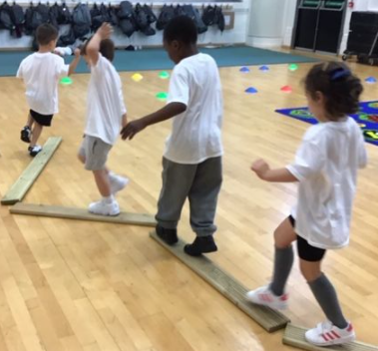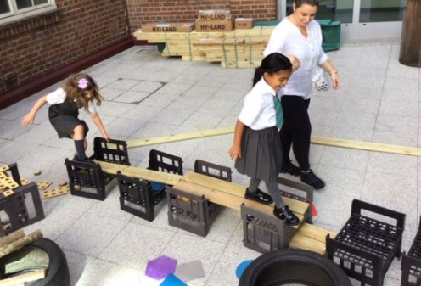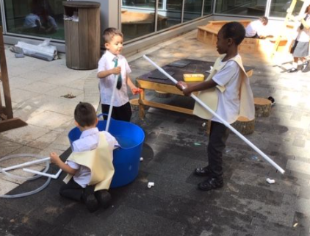
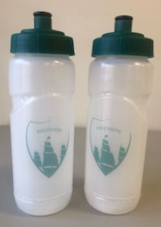
Our individual APSoL water bottles have arrived today. We are grateful to the Camoes Institute for donating one for every child.
This means that from Monday, your child will not need to bring in a bottle from home as we will fill these up at school.

Estamos muito gratos ao Intituto de Camões por nos ter oferecido estas garrafas de água personalizadas. A partir de segunda-feira, as crianças não precisam de trazer garrafa de água de casa.
Last week the teachers made a call home to update you on how your child has settled and have the opportunity to find out any queries you may have.
If you missed their call, please let us know via email and we will aim to do so early next week.
Parent-teacher meetings will be scheduled for the last week of term virtually.

