Anglo Portuguese School of London
of London
21st September 2020
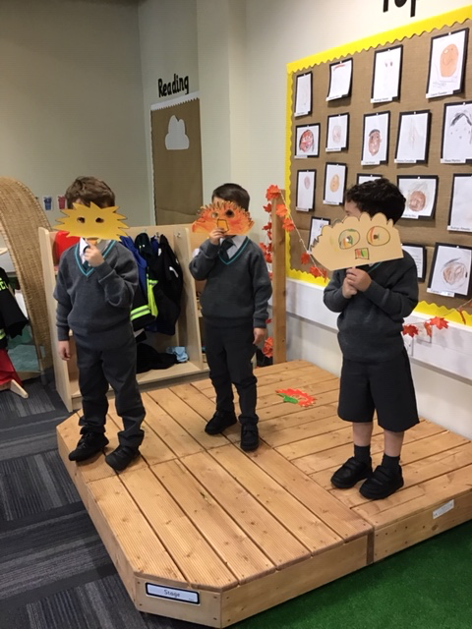

At APSoL this week;

In Literacy this week, we read the ‘Owl Babies’ by Martin Waddell and Patrick Benson. We talked about how the owls felt and labelled the characters from the story. We thought of different sentences we could write about the story and acted it out, using masks we had made.  In Maths, we have been sorting objects into groups and explaining why we have grouped the objects in a particular way. We have also been counting forwards and backwards, making sure we use one to one correspondence.  Outside, the children have continued to be interested in creating obstacle courses. Several of the children have also shown an interest in pretending to be builders, transporting materials around the playground.  Next week, we will be reading the story of Halibut Jackson, by David Lucas. A story about emotions and making new friends.  On Wednesday, please ensure your child wears the full school PE kit and blazer to school.  Wishing you a great weekend,  APSoL EYFS Team | 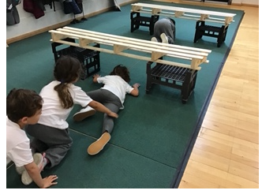  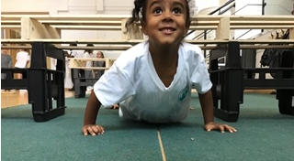 | Reminders:  Blazers must be worn to school every day. Please ensure your child wears their pullover or ensure this is in their bag. The children go outside several times and must wear their jumpers due to change in weather.  Wednesdays: Wear full PE kit to school & blazer  Tuesdays: Home reading folder needs to be brought to school  Fridays: New home reading books sent home in home reading folder
Português:
Na nossa sessão de Educação Física, estivemos a praticar a coordenação motora.
Os alunos completaram um curso de obstáculos, com desafios de equilíbrio, ritmo e agilidade. Fizemos o aquecimento ao som de músicas infantis portuguesas o que provocou bastante entusiasmo.
As instruções dos exercícios foram dadas em português usando o vocabulário aprendido.

Reading Systems
In Reception, we have already started our daily phonics sessions using RWInc phonics scheme. Please follow this link to see a RWInc video for parents: https://www.ruthmiskin.com/en/find-o
ut-more/parents/

We will be sending home-readers matched to each child’s phonetical understanding.
We would be grateful if you could read other stories (in any language) with your child too in addition to the phonics home readers.
The most important thing is to support your child with appreciation for books, discussions about covers, story predictions and questions to support their thinking.
Book bags will be sent home on Fridays. All books will be collected on Tuesdays.
Book bag contents:
- Reading Record: children need to practice reading the same book every day. This will support them with recognizing words and sounds as well as grow in confidence with the text. We would be grateful if parents could sign the reading record and write a comment. Teachers will check Reading Records on Tuesdays when these are brought in.
- Reading Book: RWInc book bag book – appropriate level for each child according to their reading.
- Zip bag: please ensure reading book and reading record are always kept inside the zip bag to prevent damage.
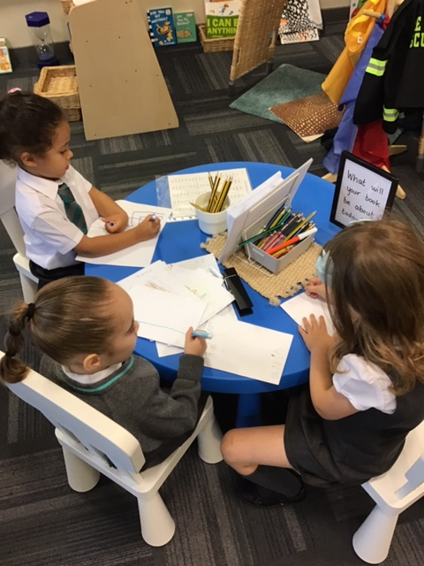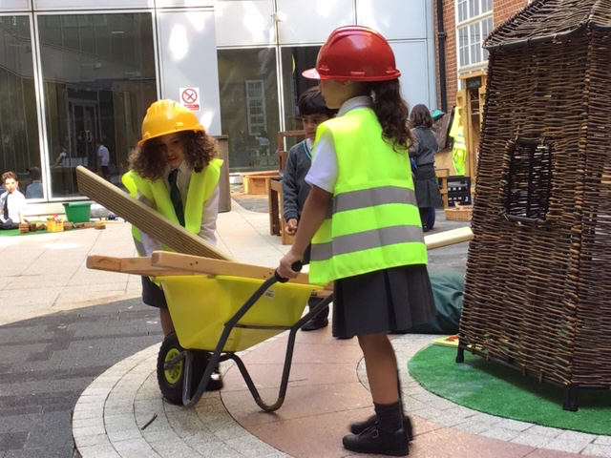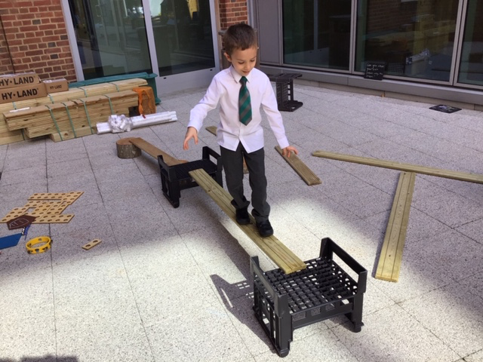
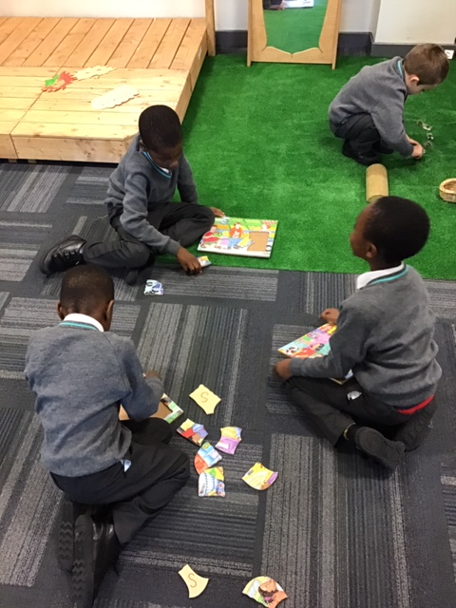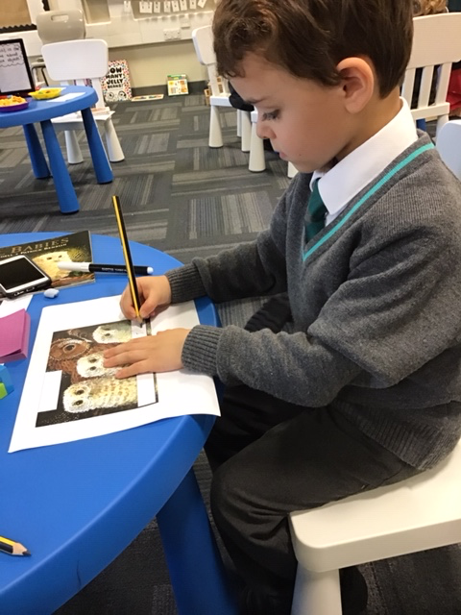
A importância da leitura em casa

Na Reception, as crianças estão a aprender a ler. O mais importante e aprenderem os sons e eventualmente os nomes das letras.
Todas as sextas feiras, vamos enviar uma saqueta com um livro e um diário de leitura. Pedimos aos pais que encorajem as crianças a ler (como sabem), falar do livro e questionarem imagens e palavras e que assinalem a leitura no diário de leitura.
Pedimos que esta saqueta com o livro e o diário de leitura, sejam devolvidos às terças-feiras para que as professoras possam trocar os livros de leitura.
Quem fez anos em Setembro?
Anna Isabel, Taylor e Nicole

A importância da leitura em casa

Na Reception, as crianças estão a aprender a ler. O mais importante e aprenderem os sons e eventualmente os nomes das letras.
Todas as sextas feiras, vamos enviar uma saqueta com um livro e um diário de leitura. Pedimos aos pais que encorajem as crianças a ler (como sabem), falar do livro e questionarem imagens e palavras e que assinalem a leitura no diário de leitura.
Pedimos que esta saqueta com o livro e o diário de leitura, sejam devolvidos às terças-feiras para que as professoras possam trocar os livros de leitura.

