Anglo Portuguese School of London
5th October 2020
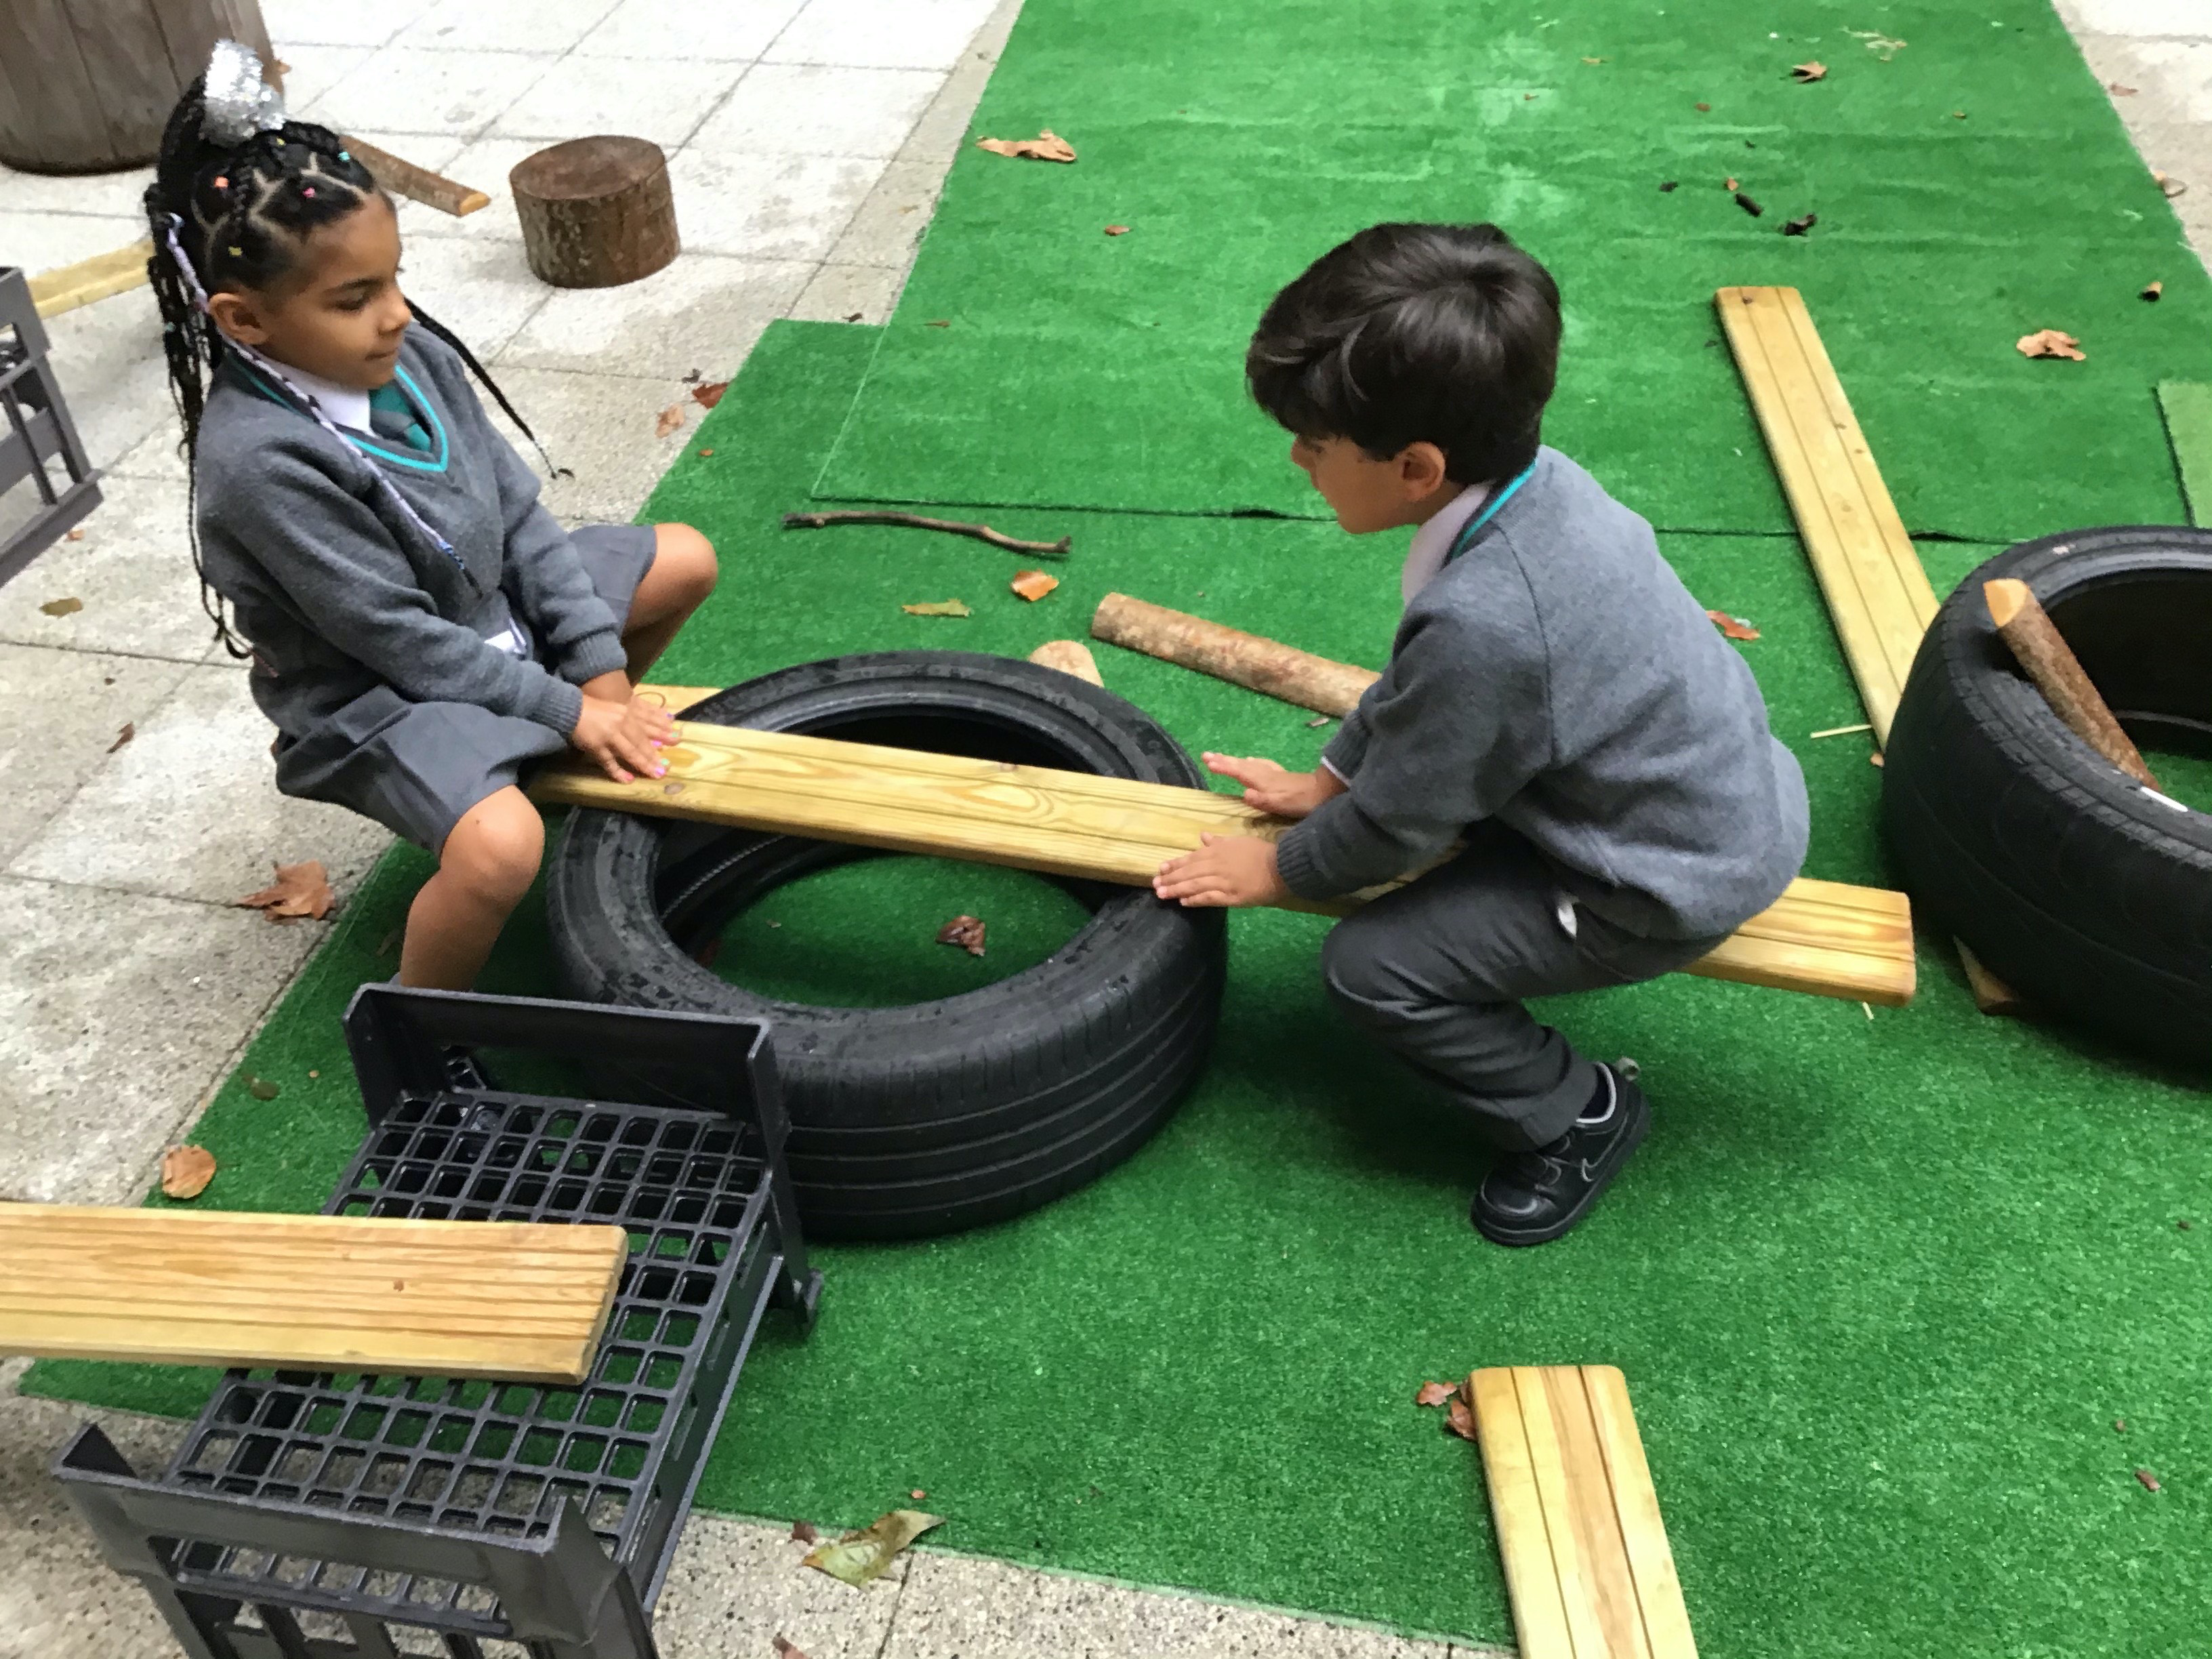

At APSoL this week;

This week we have been looking at and creating patterns in Maths. We had a discussion about what a pattern is and where we find patterns in the environment. The children all had a go at completing a repeating pattern, using a variety of shapes and objects.  Ask your child what patterns they can you find at home? Maybe go on a pattern hunt?  In Literacy, we continued to read Halibut Jackson. The children each had a go at writing some words or a sentence about themselves. The children are starting to use their phonic knowledge to form words.  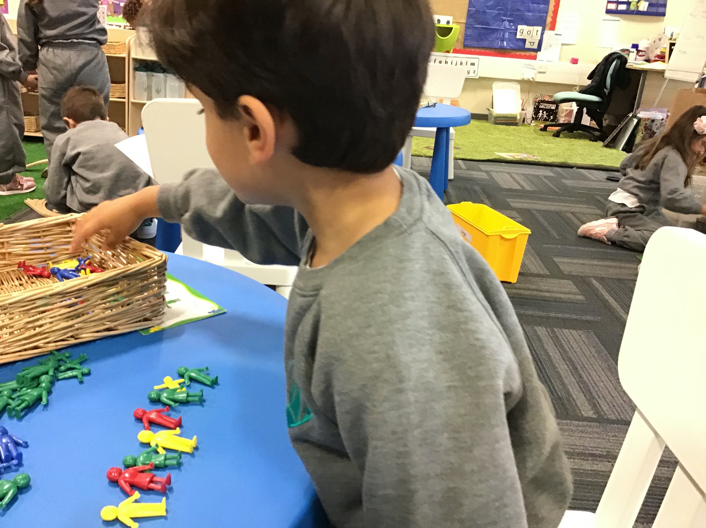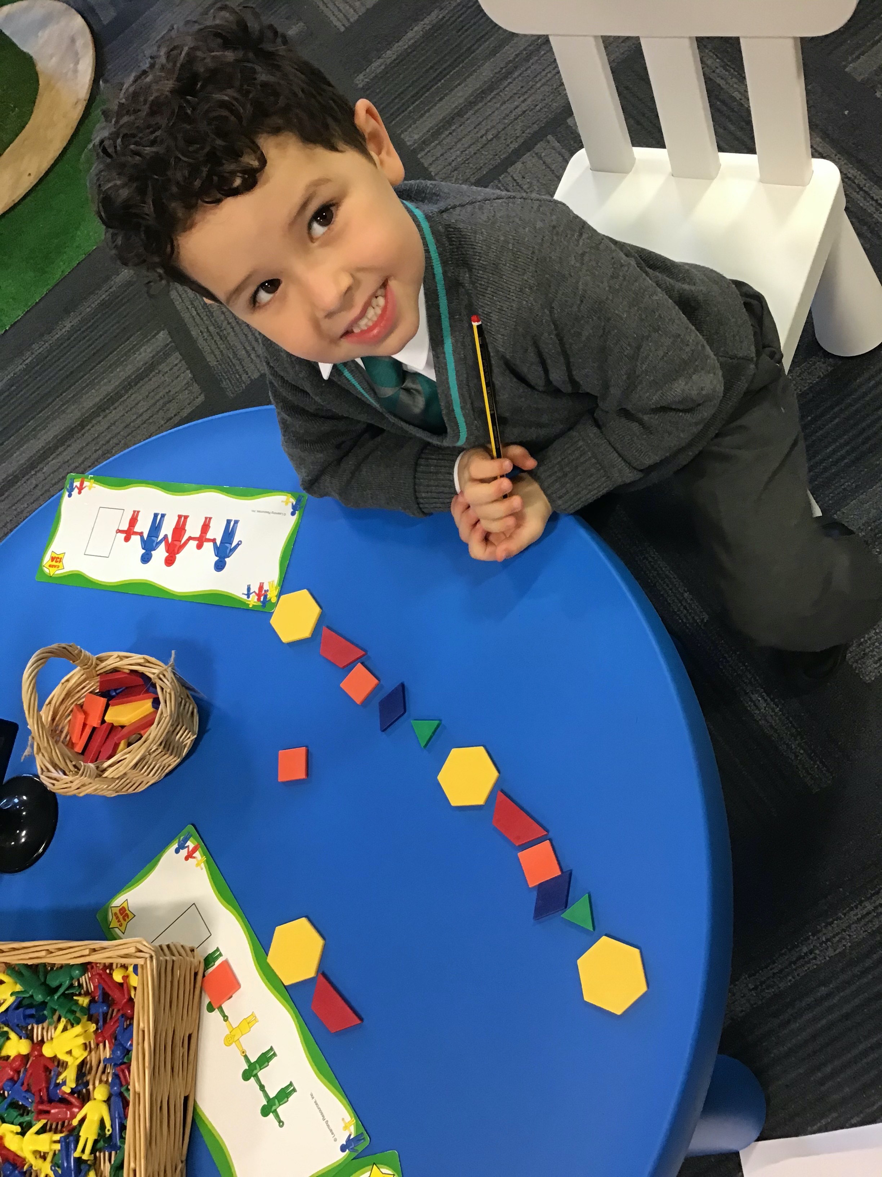  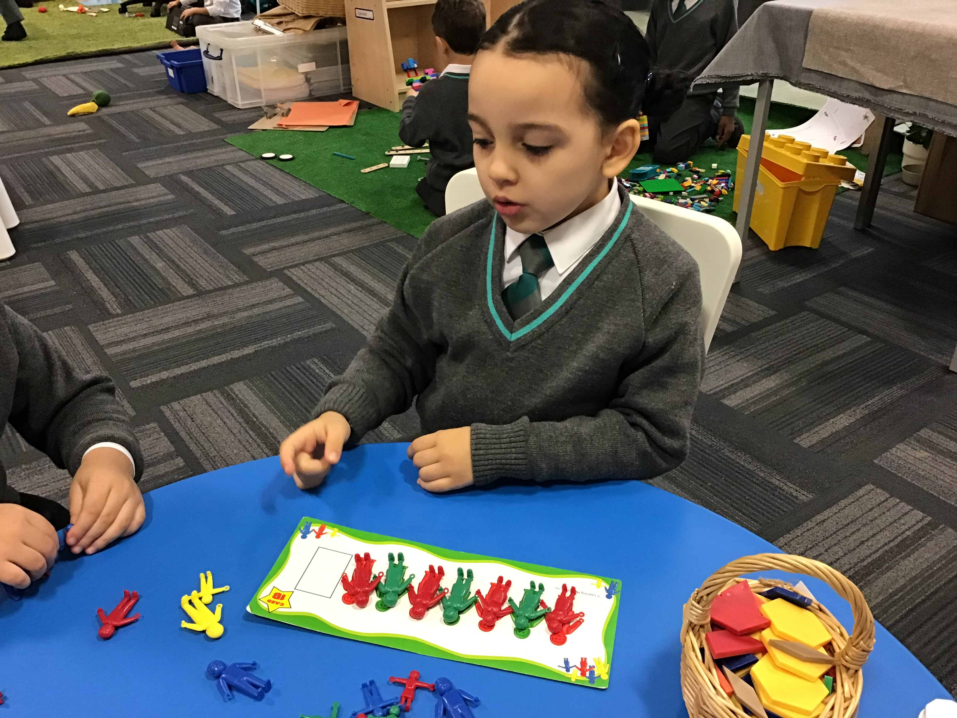  Snacks and water:  Children are allowed to bring in healthy snacks. They don´t need to bring drinks or water bottles to school as we have provided each child with one. |  | Português  Esta semana estivemos a ler o livro “O Monstro das Cores” que fala das diferentes emoções qie podemos sentir.  Os alunos falaram de como se sentem em situações diferentes e do que os faz sentir bem.  Também falámos sobre as cores, descrevendo o monstro na sua passagem pelas várias emoções.  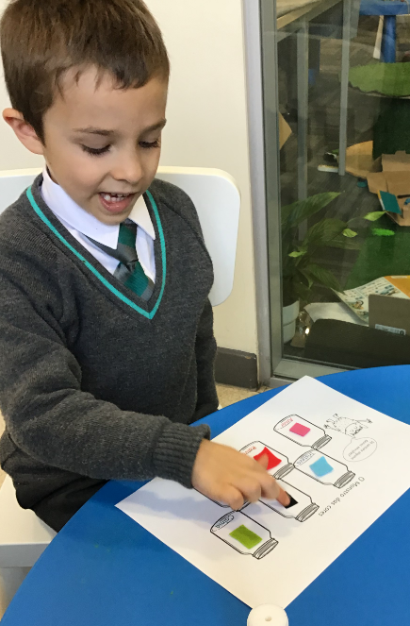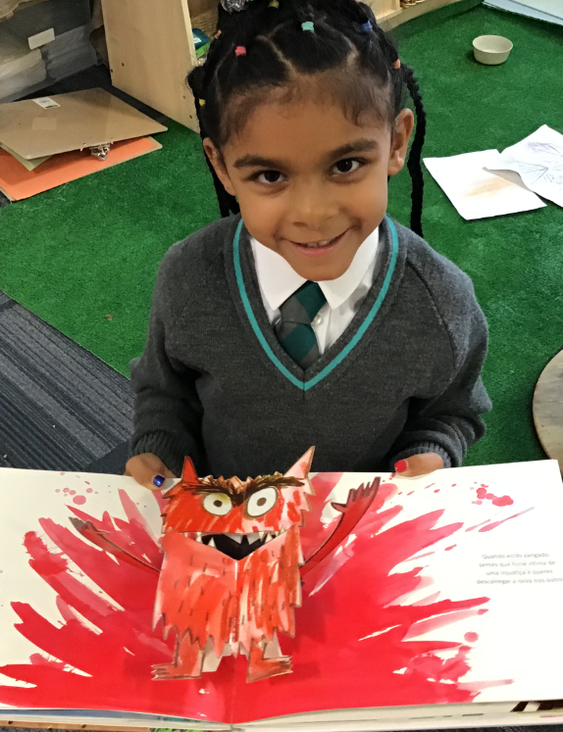  COVID guidance for families:  Please continue to help keeping children, staff and families safe by taking extra care when travelling to school on public transport and when you are out and about. As a school, we highly encourage face masks if travelling on public transport due to children having a natural instinct to touch different surfaces and then their faces. Please continue to social distance at pick-ups and drop-offs. If your child develops any of the symptoms below, please do not bring them to school and call NHS111 and NHS119 in the first instance for further guidance:  - Continuous cough  - Temperature  - Loss of or change to sense of smell or taste  Please follow COVID guidance on social distancing when meeting family and friends. The more we do to protect each other, the longer children can enjoy being at school!
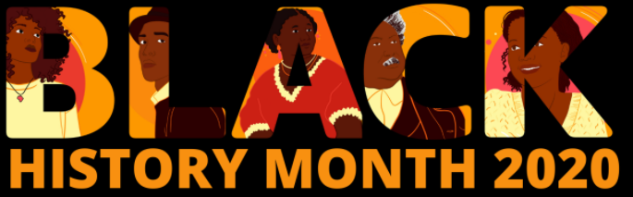
Birthdays at APSoL:

In light of COVID, we cannot accept any cake or party bags in the school premises. We will of course celebrate the children, sing them happy birthday with the class and make sure they have a very special day. We can´t however, be giving anything out which may put staff, pupils and families at risk of contracting COVID. We thank you for your understanding and co-operation.

Important dates coming up:
Friday 23rd October – School closed for children (Inset day for teachers). Parent evening zoom calls will take place on this day. Teachers will discuss your child´s development, progress and targets.
Tuesdays: bring bookbag books to school and signed reading record
Wednesdays: PE day – children wear their full PE kit and blazer to school
Fridays: New reading books taken home
Monday 26th October-Friday 30th October: Half-Term School Closed
Monday 2nd November: Term 2 starts
As this month marks Black History Month, we would like the children to look into finding out about an inspiring individual. This could be someone from history or someone living now. Some examples could be Mary Seacole or Mae C Jemison. The children could draw a picture and think of a few words to describe their chosen individual.
Please feel free to send the work in or email to us using the email below:
eyfs@angloportugueseschool.org with an explanation of the work and your child´s name.
Please note that this email is solely for submitting work, videos, songs, pictures of your child´s home-learning.
Emails regarding any other matter or queries, must continue to be emailed to info@angloportugueseschool.org

