Message from the Principal  Dear families  Happy New Year!  We were all very grateful to our families for your support with Covid management at the beginning of the term. You are all very pro-active which really does support to keep the school functioning as best as it can! Again, if you or your child test positive on a lateral flow test, or your child develops any Covid symptoms, please contact the school straight away so that we can provide guidance.  On behalf of the team, I would like to officially welcome Ms Ricardina to our APSoL family. The Reception children have settled incredibly well this term!  This term, our class topics are:  Reception -Traditional Tales (fairytales)  Year 1 - Toys (past and present)  We have very exciting workshops and trips planned for this term to further enrich the children’s learning, including a Freshwater Theatre Company workshop for Reception and Year 1 vising Pollock’s Toy Museum!  One of our parents in Reception and has offered to lead a design workshop for Reception children as they are learning about different types of houses. If you would like to get involved or have a particular interest or skill, please let us know via the school email or informing your child’s class teacher.  Best regards,  Ms Marta Correia |  | Talent Show 2022  Before half-term, the children will have the opportunity to perform in our very first Talent show! Your child’s application needs to be submitted by email.  Trips &Workshops  Year 1 – Pollocks Toy Museum 3/2/2022  Reception - Freshwater Theatre Company workshop at APSOL 20/1/2022  House design workshop with parent architect 20/1/2022  Home-learning projects  Knowledge Organizers were emailed on the first week of term. Home/learning projects are due week commencing 24th January. | Parent - Teacher Meetings  At APSoL, we truly value parental involvement and believe children achieve their best when parents are aware of the areas they need support with. As such, we are holding a parent/teacher consultation this term on Monday 7th and Tuesday 8th February, by appointment.  At the meeting you will be provided with a report that shows you how your child is progressing towards end/of/year group expectations as well as how you can support at home. |  | 14th January 2022  APSoL News  .

ent – Author visit
On Wednesday 20th September, Year 1 will be visiting the local library as they are going to have a session with an author: Thais Braga! We need two parent volunteers from Year 1 p

Celebrations!
January birthdays
Happy birthday to all these children and staff this month:
Laura G, Olivia H, Nina, Alexia, Emily
Weekly Certificates
A huge congratulations to all these children for working hard and being great school ambassadors!
Week 1 & week 2
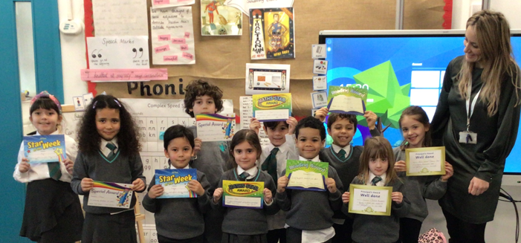
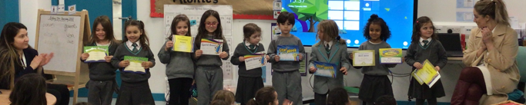

PE equipment & gym apparatus.
This week, we have also received a large PE order containing all the equipment needed for a broad PE curriculum. We are now waiting for our gym apparatus to arrive!
Our PE equipment will cover all our sports needs including dance and movement, gymnastics, games and athletics.
We have decided to set up one of our huge classrooms for PE teaching which we will use in the future when our building works restart.

At APSoL, we ensure all children get a broad physical development curriculum by following Striver PE scheme.

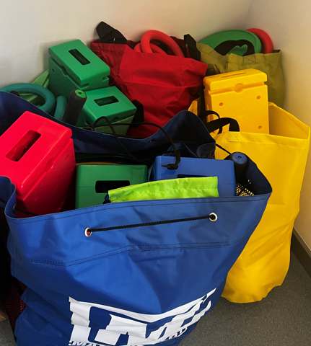
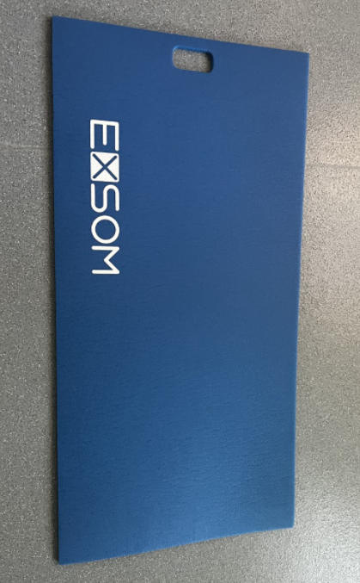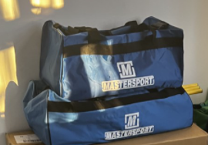
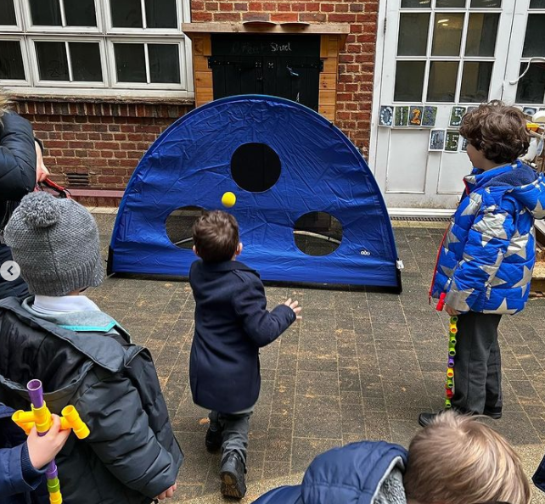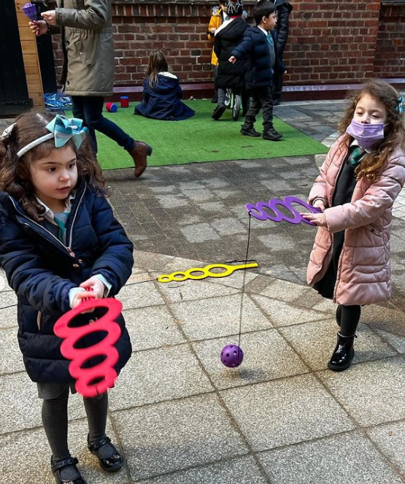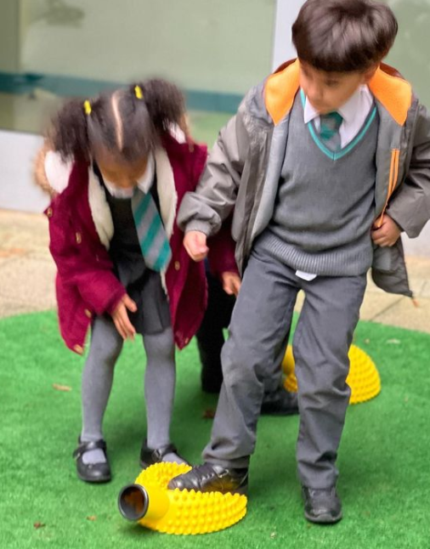
New play time equipment
To encourage social play, gross motor skills development, hand-ey coordination, we have ordered a significant amount of play time equipment which we are certain your child has enthusiastically reported!
The team have organised a play time rota where the children will have the opportunity to learn various games, songs and rhymes in Portuguese and English.

