APSoL
Early Years Brochure
2023-24

Welcome to APSoL
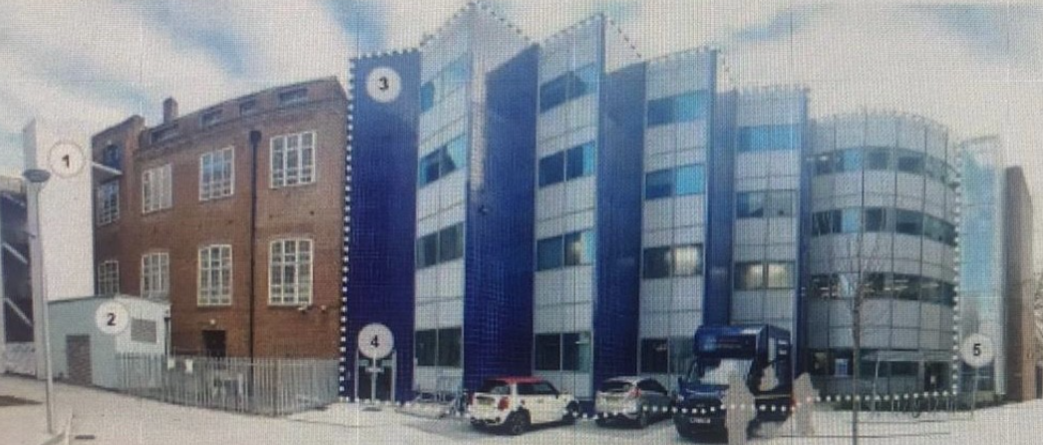
Our Mission
Our mission at the Anglo-Portuguese School of London (APSoL) is to establish an excellent school for inquisitive pupils where they will learn in both English and Portuguese languages. We will work hand-in-hand with the Lusophone community in London to establish a school that reflects the values and culture of English and Portuguese-speaking communities and cultures around the world. APSoL delivers a broad and balanced curriculum that offers pupils the opportunity to communicate fluently in two languages while also acquiring the skills necessary to cooperate, learn, and interact with each other and the world. We believe that all students can make better than expected progress and attain high standards if they learn in a high-quality bilingual environment with outstanding teaching and enrichment available in all subject areas. Our approach to bilingual teaching will include a strong multicultural dimension, including the history and geography of both England and Portugal, and the countries where these languages are spoken.

Welcome to Reception
We are delighted that your child will be joining our school´s Reception team in September and are looking to getting to know them!
Starting school should be a happy and exciting time for both your child and for you. We know that you have lots of questions to ask us and the purpose of this booklet is to begin to address some of those.
We hope that you are looking forward to joining us and taking part in all that we can offer your family. We will do our very best to make you and your child feel comfortable, secure and valued within our school community. Our aim iss to provide your child with the very best education possible and we hope that you will work with us in partnership to achieve this aim.
Yours sincerely,
Marta Correia
Principal

Staffing
Ms Marta Correia, Principal
Ms Ricardina Oliveira, Reception class teacher
Ms Alexandra Taveira, Ines Ferreira Portuguese teachers
Ms Andreia Santos, Teaching Assistant
Ms Freya Cioffi, SENCO

Reception Organisation
Our Reception has places for 30 children, we will then decide whether the children will be in one registration group or in two. Our class names across the school are Portuguese Speaking Countries.
Each class will spend some time during the course of the year, doing a locality study by exploring the city correspondent to their class name.
Each group will have a class teacher. We also have an Early Years Practitioner and a Portuguese language teacher working alongside the Reception team.
Throughout the day, children will have short input sessions in their class base but will access activities in both classrooms and the outdoors throughout the day. So there will be plenty of opportunities for children to socialise with children and staff from both classes.

What happens before my child starts at school?
June - Information evening
July - Stay and play session – uniform, passport and birth certificate

What is a virtual home visit?
Members of our Reception team, including your child´s teacher will video call each family home in order to meet each child in their own surroundings. This gives teachers an opportunity to establish their partnership with parents, making time to answer any questions and hear any concerns. In addition, your child has the chance to share toys, thoughts and feelings about starting school with their new teachers. Each video call will last approximately 15 minutes.
During the virtual home visit, staff will ask questions that will help them to get to know the child and family better. For example, information we might ask might include:
- Your child´s names and pronunciation of these
- The different languages that are spoken and understood by the child
- Your child´s main interests and special toys as well as anything they particularly don´t like doing
- What your child likes to do and play, both inside and outside.
- How your child usually reacts to new situations and new people
- Anything we need to know that will make the settling in process as easy as possible.
- Any concerns you might have about your child´s development
- Whether your child child may need any support in using the toilet, eating independently or with dressing.
- Any allergies or medical conditions your child has.
When does my child start school?
Staggered start half days – Your child will have a half day during the first week in September before starting full time. You will be informed about these sessions by email or letter.
Full- Time: All children will start full-time after their half-day session. Children will be expected to wear full school uniform including black school shoes on their first day.

Will I have a say in my child starting full time?
Parents are offered full time education for their child from the week commencing ---, providing that both the school and parents feel the child is ready for full time attendance. Such a decision is always made in partnership between home and the school.
Legally, children must begin school the term after their fifth birthday. We will work closely with parents to ensure that, when full time school begins, everyone is happy.
Reception Daily Timetable
8.45-9.00: Soft start – early morning reading systems
9.00: Registration
9.05-9.25: Literacy focus session
9.25-10.00: Free flow activities and themed group activities including Portuguese (inside and outside)
10.00-10.40: Early morning reading – phonics RWINc
10.40-11.25 Free flow activities and themed activities including Portuguese (inside and outside)
11.25-11.45: Maths focus session
11.45-12.45: Lunch service & Lunchtime games including Portuguese (inside and outside)
12.45-1.05: Registration and Topic focus session
1.05 -2.05: Free flow activities and themed group activities including Portuguese (inside and outside)
2.05-2.25: Portuguese session
2.25-3.30: Free flow and themed activities (inside and outside)
3.30-4.00: Portuguese story time and home time organisation
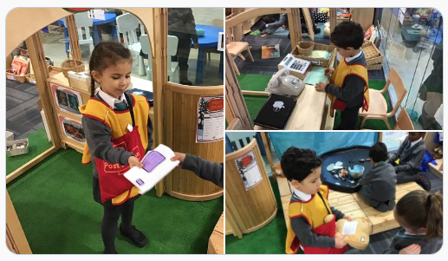
Early Years Key Workers
A key person has special responsibility for working with a small number of children, giving them the reassurance to feel safe and cared for, and building relationships with their parents. Key workers have an important role to play at the start of the year when the children are new to school or are moving to a new class. Your child will be allocated their own key person who will be introduced to you at the start of the school year; it may be your child’s class teacher or teaching assistant.
Key workers have responsibility for the settling in process, assessment/record keeping and parental liaison for the children in his/her key group. The class teacher will oversee the key workers working within his/her class. We have an open-door policy for parents. Please feel free to come and see your child’s key worker or class teacher about any aspects of school or your child’s learning. We need to give our full attention to all of the children at the start of the school day but we are happy to talk to you after school or with prior notification during the school day. You can make an appointment with us or at the school office.

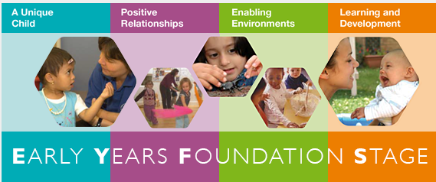
Early Years Reception – Our Bilingual Curriculum
Our curriculum plan is developed with reference to the statutory framework for the Early Years Foundation Stage March 2017, teaching and learning experiences are planned across the seven inter-connected areas of learning and development:
The Prime Areas
❖ Communication and language
❖ Physical development
❖ Personal, social and emotional development
The Specific Areas
❖ Literacy
❖ Mathematics
❖ Understanding the world
❖ Expressive arts and design

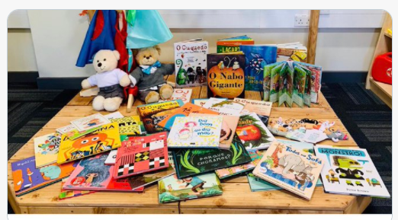

The Enabling Environment
We have a workshop style environment inside and outside. The resources and materials available to the children are of a high quality, open-ended, well-ordered and accessible to the children. They are carefully selected for their potential to promote learning and sustained high-level involvement. Resources and contexts are available which motivate the children to explore and problem solve, play imaginatively and make representations (to paint, draw, create models, dance and make music). Resources are always available in all areas to motivate children to investigate with numbers, shapes, space and measures and to practice their emerging writing and reading skills. Children's work is valued and displayed and interest displays are set up to encourage the children to explore and ask questions. Labels and signs are displayed in both English and Portuguese. Resources are stored so they are easily accessible to the children. This helps them develop as independent learners. Children are encouraged and taught how to treat resources with care and respect. At the end of each session they help to tidy the classroom and put away equipment. Sorting equipment also helps with mathematical learning. Children are encouraged not to waste expensive consumable resources, they learn to recycle paper and with the encouragement of their parents to collect junk materials, as these can often be a useful learning resource.
Planned Enhanced Provision
In addition to the ‘continuous provision’ we enhance our provision in relation to the half-termly theme. We plan six half-termly themes with reference to our whole school curriculum resources (Creative Cross-curricular Curriculum, Whiterose Maths [mastery approach], Portuguese curriculum).
The Team plan a theme map with possible activities, the themes are then developed in response to the knowledge and interests each group of children brings to their class. The theme begins with a class knowledge/interest. The themes integrate learning across the seven areas of learning which form the basis for the Foundation stage framework. Each theme is launched with an exciting entry point activity and concludes with the exit point review, often some form of trip or celebration.
Our theme plans include a Lusophonic perspective to reflect the bilingual focus within our school. Enhancements might include visits to a place of interest e.g. a bus trip around the local area, or visitors to school e.g. a children’s farm. They might also be an exciting experience such as hatching chicks or observing the lifecycle of a butterfly. Stories/texts are selected each week and explored through storytelling, role play, story props and sequencing cards. Theme related role play areas are developed and modelled for the children e.g. a garden centre, doctors’ surgery.
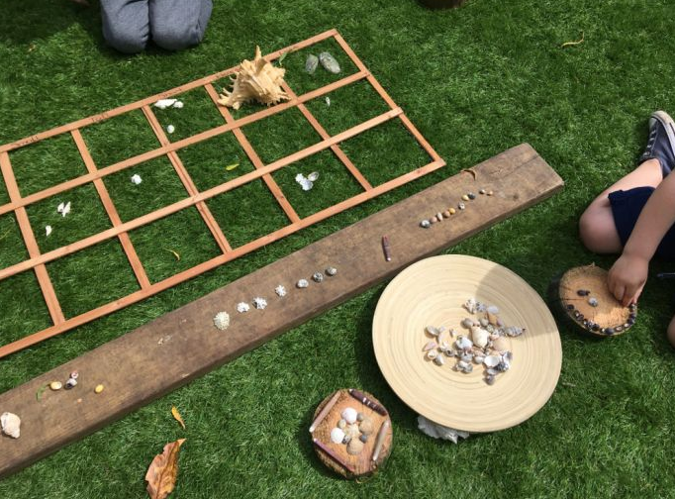

Teaching and Learning in Reception
Adults support learning during activity time by:
• Encouraging children to choose activities inside and outside, and to sustain interest in their activities;
• Modelling to children how to respect, play with, look after our resources;
• Providing challenge and questions at the level which is right for the child in order to move the child’s learning forward there and then-‘in the moment planning’. These crucial moments of teaching occur throughout the day across many situations and interactions;
• Knowing the children in their care well and having knowledge about their interests and next steps in their learning;
• Recording key moments of progress in a child’s learning - ‘wow moments’ - using the a safe online assessment tool.
The key information recorded includes; What the adult observed, what the adult taught the child or group and what was the outcome.
Planned adult input sessions: These are sessions when adults teach key concepts in small or larger groups. They happen a number of times throughout the day e.g. phonics (RWInc Phonics) takes place for 20 minutes.
Planned adult input sessions in Reception: Story/theme input, phonics, maths sessions, individual/paired reading, story scribing.
The children also have opportunities to practise their skills and new learning in small guided groups with their teachers and independently in provision.
Literacy: Adult input for literacy is based around the books selected for the term; children develop an enjoyment of a variety of quality texts and traditional stories. They also have many opportunities to mark make, retell stories, and explore language during the day through the enabling environment. Adults support early writing through ‘Story Scribing’ which has a high priority in the daily program. Daily opportunities are planned to develop gross and fine motor skills which are crucial to support pre-writing skills and handwriting development.

Daily phonics lesson:
We use the ‘RWInc scheme; a quality synthetic phonics programs. Phonics skills are modelled to the children and they then have opportunities to apply their skills both in writing and reading activities.
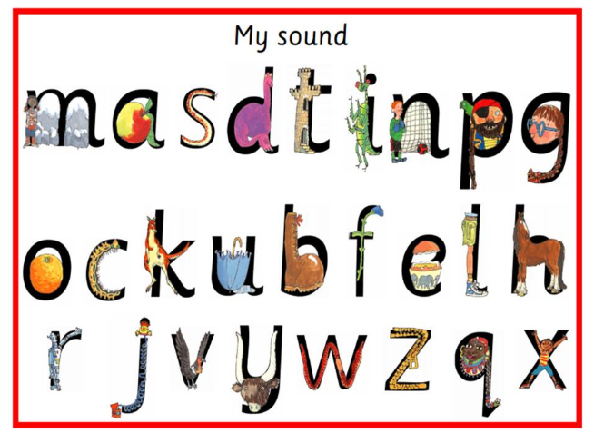
Portuguese teaching:
On the Early Years staff team, we will have a Portuguese bilingual team, which will consist of a teacher and assistants. In the afternoon the children are taught in Portuguese using an immersion language program.
Portuguese immersion education: all teaching and modelling by the practitioners is in Portuguese. The children will take part in small group activities linked to the topic. These activities will be delivered entirely in Portuguese with the teacher using gestures, pictures and symbols to help the children access the language at their level.
In the first half term, there will be a strong focus on simple communication, for example; routines and language of the classroom. Children who already speak Portuguese at home will be provided with extension activities and many opportunities to progress further with their Portuguese language skills. The children’s progress in Portuguese is assessed using the school’s language ladder.
Early Years Reception Outdoor Learning
Outdoor Play: The outdoor environment is as important as the indoor space as an environment for teaching and learning. Children's sensory and investigative skills are developed by their involvement in gardening and exploring in the garden areas. The children have access to fruit and herb gardens and are involved in planting flower and vegetable gardens. They help to care for the plants, water and harvest the produce and investigate the mini beasts and birds attracted to the gardens.
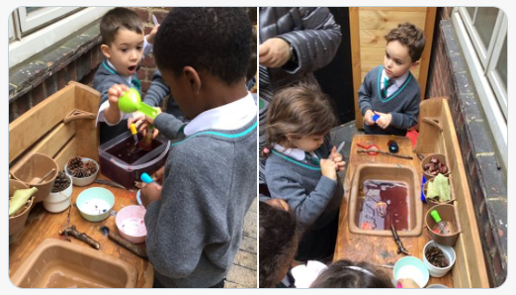
Literacy and Numeracy: Learning in these key areas of the curriculum is also enhanced by outdoor learning opportunities; children go on letter, text and shape hunts, step along giant number lines, play active phonics games, retell stories and write for purpose during outside time.
Topic themes: The topic theme can be developed further in the large outdoor space. For example, children can dress up and explore what it is like to be a member of the emergency services or the postal worker delivering the post to different addresses, they can investigate forces by finding out how sand can be moved with pullies and wheelbarrows, they can make large scale paintings and models together.
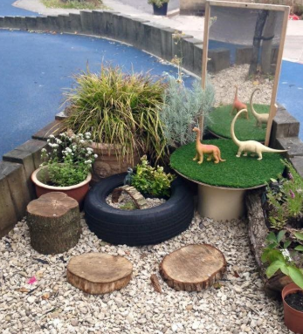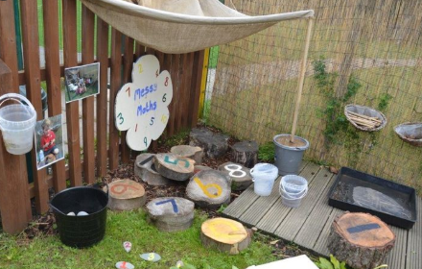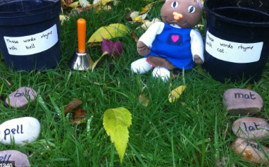
Physical Play: Our large outdoor space allows us to provide daily physical play, climbing, dancing, play with small PE equipment and large construction toys. Physical play is very important for young children. By encouraging young children to enjoy being active we establish positive attitudes to exercise as they grow older. Through physical play, children develop spatial awareness and motor skills which are crucial in their later literacy and numeracy development. They also learn the important skills of co-operation, sharing and turntaking.
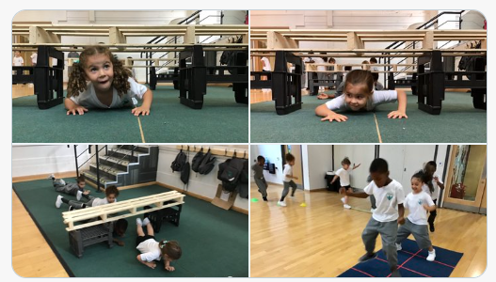

Reception Learning Environment, Approaches and Communication Systems
Observations to Support and Extend Learning: All early years practitioners working in our school are trained to closely observe and evaluate the children's learning. Through observation, we will be able to assess the children's progress and acquisition of skills. This enables us to plan new activities and provision to extend their learning and to set specific next steps for individual children and groups of children. As children progress through Reception, we monitor their achievements and development closely across the seven areas of learning. Each week, we collate the observations, which along side samples of the children's work and photographs of their involvement in activities, enables us to complete an individual profile which celebrates the child’s learning journey during the Foundation stage.
Reception Learning Environment: The team in Reception provide an attractive and stimulating environment in the unit. Children's work is valued and celebrated and interest displays are set up to encourage the children to explore and ask questions. Labels and signs are displayed in both English and Portuguese. At APSoL, we believe that using natural and reclaimed material allows children to use their imagination and demonstrate their skills, for the younger children it can enhance their sensory development. An advantage of using natural materials in the environment is that children will often make connections with these in their home environment. We have therefore selected natural materials for furniture and play equipment as the environment can be enhanced with colour through children’s work. This is also our ethos for the outside learning environment.
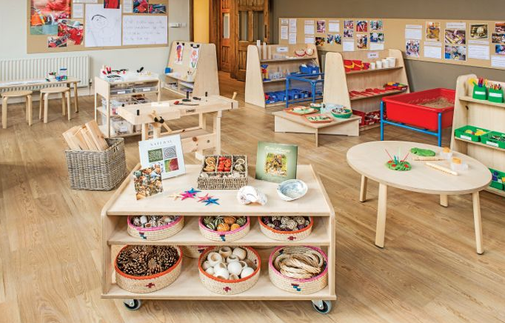

Promoting Positive Relationships
The early years unit is organised so that children have their own class base for example: literacy, numeracy, topic and circle time.
But they also have opportunities to work and play with children from the other two classes for example: during free-flow, PE, music and Portuguese.
The children soon develop a class identity and build relationships with their peers and adults. Weekly circle times help children develop tolerance, co-operation and positive relationships. These important skills are continually promoted and reinforced during daily activities. Children are encouraged to work and play together, to share but also to become aware of the importance of personal space and quiet solitary play at times.
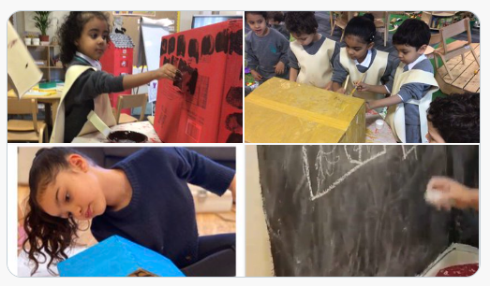
Adult to Child Ratios in Reception
In our Reception classes, we provide high adult to child ratios; it is important for young children to have a good level of small group and individual support from practitioners. With good adult to child ratios, we are also able to provide a good level of care for the children, to support them with developing self care skills and building relationships.
Each Reception class teacher is supported by a teaching assistant and a Portuguese teacher. This is in line with the statutory Framework for the Early Years Foundation Stage (DFE 3 April 2017).
Transition Arrangements
Many of our Reception children will have previously attended other early years settings. Wherever possible, children are visited in their previous daycare setting and practitioners liaise closely with the children’s previous key workers. We are always interested to read the children's transition reports. This information helps us meet the needs of each child as they start in our school. Before children start at APSoL in Reception, we provide opportunities for them to meet their peers and the team as well as see the learning environment so that they are familiar with the setting before they join.
Our children have some staggered sessions to support them with transitioning to Reception. These are half-day sessions where their parents can stay. Children may wish to bring a soft toy or a comforter for the first days of primary school and we support this as part of their transition.
Partnership with Parents
We welcome parents in to work with us in the classroom. Please help us enrich the children’s learning by sharing your skills. You can take part in cooking, singing, dancing, making, reading, gardening and so many more activities with the children.
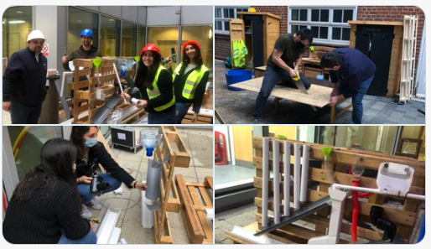
Absence from School
Encouraging good attendance is a school priority and it is very important that you avoid unnecessary absences for your child. Please telephone the school on the first day of absence, to explain the reason why your child will not be in school. We are required to record reasons for absence in our registers. Failure to explain absences will result in the absence being unauthorised. Holidays during term time will not be authorised unless there are exceptional circumstances and taking children out of school for a holiday may result in a fine from our Educational Welfare Officer.
Reception lunchtime
Children use the buffet service helped by the Early Years meal supervisors and have their lunch in their environment.
Pupils in Reception, year one and year two are able to have a free school meal under the government initiative, “Universal free school meals” introduced in September 2014. Please indicate on your data collection form whether your child will be bringing packed lunches or having a school meal.
Packed Lunch: It is the school policy that children should not bring cans of fizzy drinks, glass bottles, sweets or chocolate in their packed lunch. For more detailed information please see the school healthy packed lunch policy. If you want to change between school dinners and packed lunch, you can only do so at the start of a half term. Please notify the school in writing of such a change. We need to know what your child’s lunch arrangements are going to be before the end of term, and where necessary have all the paperwork in place so please ensure you have let the school know your child’s meal arrangements.
Snacks
Milk: As fresh milk is an important part of a child’s diet all children under the age of five years in Reception classes are entitled to a daily carton of free milk. In the half term a child turns five milk is still made available; for children entitled to benefits based free school meals milk continues to be provided free of charge. For all other children, over the age of five, milk is available at a subsidised cost. Please complete the registration form enclosed with this pack and return it to the school if you would like your child to have milk each day.
Water: All children should have a named water bottle in school each day. Water only is permitted in the classrooms.
Fruit snack: We encourage healthy eating at school. In both the morning and afternoon the children have a fruit snack. The school is a member of the "Fruit for Schools” scheme, providing each child in the Early Years Foundation Stage and KS1 with a daily free piece of fruit.

Additional childcare facilities at APSoL
APSoL provides before and after school care for working parents, those in further education or those parents who simply want their children to participate in a range of fun and exciting activities: for example dance, art & crafts, cooking, ICT and various games and play activities.
Before and After School Care operates at the following times:
Breakfast club: 7.45- 8.45 (£ on school website)
After School Care: 16:00 – 18.00 (£ on school website)
If you require any further information or would like to register your child for extended care from September onwards, please complete the Wrap Around Care request form included in this pack.
Medical Needs and Medication at School
We will ask you to complete a medical form for our records giving details about your child's health and your doctor's name and address. It is important that this information is updated when necessary by the parent/carer.
Medicines: If your child is well enough to attend school but still needs some medication, we can only administer it if we have your written consent with full details of the dosage required.
Asthma inhalers: If your child needs to use his/her inhaler during the day we will keep it in our first-aid cupboard. Details of the times and prescribed doses should be included so that our first-aid staff can administer it.
Headlice: Headlice are an ongoing annoyance in all schools and early years settings. If it is noticed that a child has headlice eggs in their hair we will inform you at the end of the day, however if live headlice are noticed we will contact you to ask you to take your child home in order that he/she be treated. Information on how to treat headlice is available from your health visitor, GP or pharmacy, as are the various treatments

Identification of Special Educational Needs
If a child has difficulty accessing the Reception curriculum because there is a delay in their communication and language development, personal and social development or physical development, we will identify their special educational need as soon as possible.
We will put in place an Individual program and decide how we can best meet the child's needs. This may include support from outside agencies.
We closely review the progress of children with SEN. If any concerns were raised about your child’s development or learning at their 2-year-old progress check please share your child’s plan with their new teacher and the SENCo at the initial parent conference.
This information will help us to plan targeted provision for your child before they start school. For any SEN related queries, please speak to the Principal in the first instance.
Further Enrichment in Reception
School Trips and Workshops in Reception:
We extend our classroom provision with a range of interesting trips and out of school activities throughout the year. Places visited include City farms, Battersea Park and the local area. Parental help is always welcomed on our trips so please come along if you can. We also arrange for visiting specialists and resources to enrich the curriculum such as the planetarium show, road safety show, scooter training, chick hatching.
Parental Contributions:
We provide our children with regular malleable (dough, cornflour paste) and cooking activities. These sessions are extremely popular with the children. We will ask for a small contribution from time to time to support with these resources.
School Uniform:
Wearing school uniform is compulsory at APSoL.
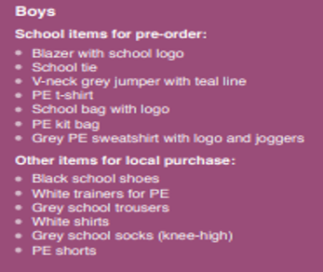 | 